A Science Fair to Remember
Students show off their winning projects at the third annual White House Science Fair
April 24, 2013
By Kelli Plasket with additional AP reporting
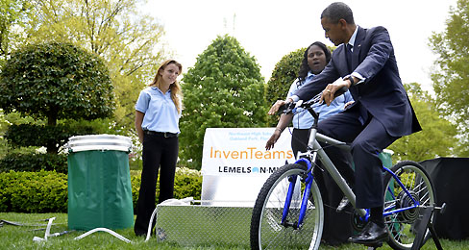
MARVIN JOSEPH—THE WASHINGTON POST/GETTY
President Barack Obama tests a bicycle-powered water filtration system invented by a team of high schoolers from Oakland Park, Florida, as students Payton Karr and Kiona Elliot explain the project at the 2013 White House Science Fair.
President Barack Obama rode a bicycle at the White House Science Fair on April 22. But it wasn’t an ordinary bike. As he pedaled, the President stayed in place, while the energy from his pedaling powered a water filtration system. He was testing an invention created by a team of 14 students from Northeast High School, in Oakland Park, Florida.
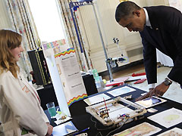
AUDE GUERRUCCI—GETTY IMAGES
President Obama looks at a robot that can paint, a project created by 11-year-old Sylvia Todd from Auburn, California, in the State Dining Room of the White House during the White House Science Fair on April 22.
Payton Karr, 16, and Kiona Elliot, 18, attended the fair as representatives of the project, which was created through a special grant from the Lemelson-MIT InvenTeam program. “We were hoping President Obama would ride the bike, but we didn’t actually expect him to,” Payton told TFK. “It really meant a lot.” Kiona agreed. “It was pretty awesome to see something that a group of 14 high school students and one teacher—along with the help of community members—got the interest of the leader of our nation,” she said.
The InvenTeam project was an idea that came about after one of the Northeast students, Kalie Hoke, visited Haiti after the devastating 2010 earthquake and saw how difficult it was to find clean water. The students invented a portable, bicycle-powered emergency water sanitation station, which can provide 20-30 people with about a gallon of drinking water in a 15-hour period. The teens hope their invention will one day be used by relief organizations like the Red Cross. “They can take it to places after natural disasters so that water can be clean and useful for the people there,” Peyton said.
Science of Invention

AUDE GUERRUCCI—GETTY IMAGES
President Obama checks out Cool Pads, an invention created by Evan Jackson, Alec Jackson and Caleb Robinson, students from Flippen Elementary School in McDonough, Georgia.
Payton and Kiona were among the 100 students from more than 40 states invited to the third annual White House Science Fair, in Washington, D.C., which is also attended by leaders in science and education. President Obama started the event in 2010 as part of his Educate to Innovate campaign to inspire students interested in STEM (Science, Technology, Engineering, Math) “If you win the NCAA championship, you come to the White House,” Obama said when he first announced the fair. “Well, if you’re a young person and you produce the best experiment or design, the best hardware or software, you ought to be recognized for that achievement, too.”
The projects at this year’s fair also included rockets, robots and even sports equipment. Evan Jackson, 10, Alec Jackson, 8, and Caleb Robinson, 8, from Flippen Elementary School in McDonough, Georgia, showed off their Cool Pads invention, which the students created to help football players stay cool on the field. The sports pads have build-in temperature sensors to help keep players from overheating. They can also be filled with water or sports drinks, so players can stay hydrated on the field.
President Obama praised the projects during a speech to attendees after the fair. “The science fair projects of today could become the products and businesses of tomorrow,” he said, mentioning the Cool Pads as an example. “If you’re inventing stuff in the third grade, what are you going to do by the time you get to college?”

