Engineering Challenge
Water Resources
Challenge: Build a reservoir that will hold the most milliliters of water within one end of the plastic container.
- Construct reservoir.
- It cannot have any leaks.
- Measure the amount of water it can hold in milliliters before flooding over the top.
Materials provided:
Clay, straws, sporks, pipe cleaner, mesh, plastic wrap, foil, plastic cups,

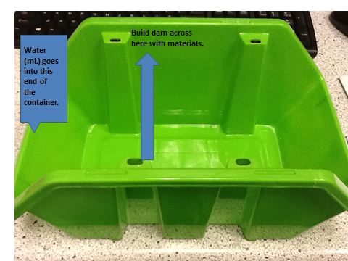

For the second challenge:
Increase the incline at the end of the plastic container of the reservoir to increase the force of water acting on the reservoir wall. The maximum incline in centimeters is illustrated below using a second container. This is the maximum of 9 cm in diagram.
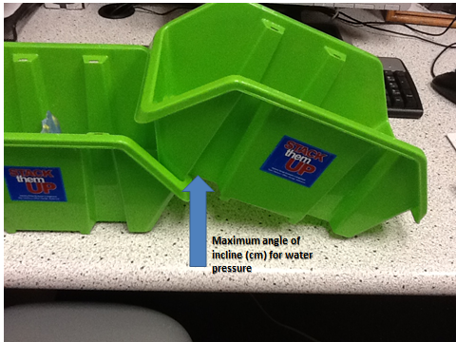
Extensions/Enrichments
Challenge: Create a fish ladder to enable fish to swim up the reservoir.

Challenge: Create diversion tunnels to divert extra water over top during rainy season.

Challenge: Limit the amount of water that can escape through the diversion tunnels.

Challenge: Use gravel, sand, and rocks instead of clay to create a working reservoir. This is somewhat tricky without something to cement the materials together.

Resources and extensions for Water activity
Fast Facts
- Since 1950, the number of large dams has climbed from 5,000 to more than 45,000—an average construction rate of two large dams per day for half a century.
- Globally, 364 large water-transfer schemes move 14 trillion cubic feet (400 billion cubic meters) of water annually from one river basin to another—the equivalent of transferring 22 Colorado Rivers.
- In the ten years since the Edwards Dam was removed from the Kennebec River near Augusta, Maine, populations of sturgeon, Atlantic salmon, and striped bass have returned in astounding numbers, reviving a recreational fishery that adds $65 million annually to the local economy.
Ipad App Cost: $1.99
Great water cycle resource will demonstrate during class. Water cycle HD
Resources:
Lesson plans for extensions/enrichment
http://www.ei.lehigh.edu/eli/energy/resources/handouts/labs/hydrodam_demo_teacher.pdf
http://www.teachengineering.org/view_activity.php?url=collection/cub_/activities/cub_dams/cub_dams_lesson02_activity1.xml
http://www.eeweek.org/assets/files/Be_Water_Wise/Atlanta/can_your_dam_hold_water.pdf
Media
Baldwin Dam video
http://www.youtube.com/watch?v=kIeNM8cm6J8
Largest Dam in the World
http://www.youtube.com/watch?v=b8cCsUBYSkw (24:35)
Worst dam collapse (1:19) No sound just pictures
http://www.youtube.com/watch?v=990HdxfEB0I
Hoover Dam Bypass
http://www.youtube.com/watch?v=be0H4ju60f0
Water Flows: Dams and Reservoirs
http://www.youtube.com/watch?v=o2qCD8j2CrM
Water Flows: From Dam to Tap
http://www.youtube.com/watch?v=u343fswe7oU
Water Flows: Ecological Effects of Dams and Reservoirs
http://www.youtube.com/watch?v=fD0hbeIAaCo
Engineering jobs in water resources (job goals at 8:53 to 10:23 in video) Water and Environmental Resources Engineering
http://vimeo.com/15886363

