Evaporation

What is Evaporation?

Draw a picture:

Question:
- When do you see more evaporation?

Experiment #1 :

Draw a picture:

Observations:

Conclusion:

Experiment #2 :

Draw a picture:

Observations:

Conclusion:

Experiment #3 :

Draw a picture:

Observations:

Conclusion:

Precipitation

What is precipitation? The act of water falling to earth.

Draw a picture:
\

Different types of precipitation
Air Temperature in the cloud is above32°

Air Temperature below the cloud is above 32 °
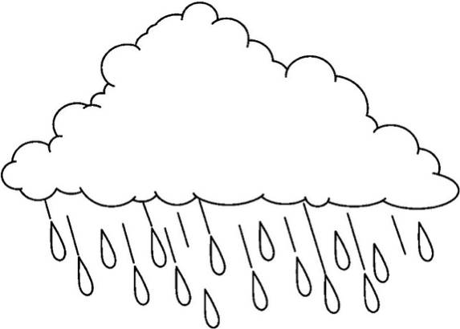

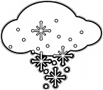
Air Temperature in the cloud is below 32°

Air Temperature below the cloud is 32 °

Precipitation

What is precipitation?

Draw a picture:

Different types of precipitation

Condensation

What is condensation?

Draw a picture:

Question:
- When do you see condensation?

Experiment #1 :

Draw a picture:

Observations:

Conclusion:

Experiment #2 :

Draw a picture:

Observations:

Conclusion:

