Grasses and Grass-like Plants of Utah
Prairie June Grass:  Prairie June Grass is an excellent forage plant for all classes of livestock. It provides good forage for wildlife in spring and in the fall. It furnishes food for small mammals and birds. It is an excellent erosion control plant. | 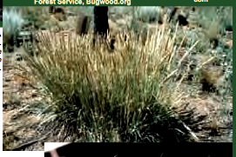
Thurber’s Fescue:  Thurber′s Fescue provides abundant forage for cattle, sheep, horse, bison, elk, and deer. It is most preferred during early spring growth prior to  flowering. It is used as food and cover by birds and small mammals. It provides moderate erosion control and is adapted for roadside seedings in areas receiving more than 20′′ of annual precipitation. | 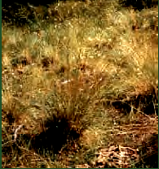
Sheep Fescue:  Sheep fescue is a valuable forage grass for all livestock. It starts growth early in the spring and tends to remain green late into the season. It is  resistant to drought and heavy frost. Commercial varieties are used in lawn seed mixes, for erosion control, or as ornamentals. | 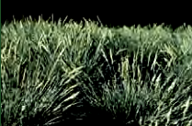
Green Bristle Grass:  Green Bristle Grass is considered to be weedy or invasive. It may be known by one or more common names in different places. | 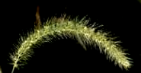
Oniongrass:
Oniongrass is an excellent forage plant for all classes of livestock, elk, and deer. A variety of small animals use both the seeds and the bulbs. It is an attractive plant of interest for its structural characteristics. It is fair to good as a plant for controlling erosion along with other plants but not very effective as a soil binder in pure stands.

Stink Grass:  Stink Grass can be poisonous to horses, especially when eaten in large quantities. However the smell may discourage consumption unless other forage is lacking. It has little value for wildlife or soil erosion control. | 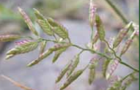
Smooth Brome:  Smooth Brome provides excellent forage for all classes of livestock and for wildlife. It provides excellent soil erosion control and is used widely for rehabilitating areas for wildlife habitat, landscape beautification, cover for recreational areas and campgrounds, roadside plants, and for ski slope and watershed stabilization. | 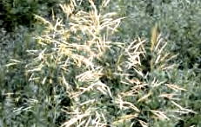
Sand Bluestem:  Sand bluestem is good to excellent forage for both livestock and wildlife. It does not do well with season-long or heavy grazing. It is excellent for erosion control on sites which are sand, loamy sand or sandy loam, especially in areas prone to blowouts. | 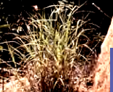

From: Grasses and Grasslike Plants of Utah a Field Guide
Utah State University Cooperative Extension

