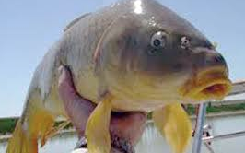
4th Grade
Standard V
Objective 2: Describe the common plants
and animals found in Utah environments
and how these organisms have adapted to
the environment in which they live.
Objective 4: Observe and record the
behavior of Utah animals.

Where Have the June Suckers Gone?

Step 1: The Problem

Fish populations have changed over time in Utah Lake. Native fish have become extinct or reduced in number and non-native fish populations have grown. Why have fish populations changed?

Write down your thinking:

Discuss your thinking with another student.

Step 2: Reading and processing information about the question.

1. Choose one person to keep the group on-task and everyone participating.
2. Read the historical events silently. Each person checks off the dates that seem most important to explain the answer to the question.
3. Discuss the dates and information each group member chose.
4. Come to agreement about the most important dates.
5. Talk about how to explain why each date is important.
6. Each group member writes down the date and why it helps understand the question.
Summary statements:

Utah Lake Fish Populations

Native Fish Non-Native Fish
Year | June Sucker | Utah chub | Bonneville cutthroat trout | Common Carp | Historical Events
1875 | 1,800,000 | 450,000 | 580,000 | 0 | 1776: Escalante describes Utah Lake in his journal: It "abounds in several kinds of good fish, geese, beaver, …. Round about it are these Indians, who live on the abundant fish of the lake”.
1885 | 1,825,000 | 425,000 | 525,000 | 2,000 | 1849: Rivers running into Utah Lake are redirected into canals. As a result many fish are carried into canals and onto farmer’s fields rather than back to the lake.
1895 | 1,775,000 | 350,000 | 400,000 | 21,000 | 1890’s: Rivers going into Utah Lake are drained in an effort to water farmer’s dry fields. Thousands of native fish die.
1905 | 1,830,000 | 380,000 | 390,000 | 435,000 | 1906: “We found the Bonneville cutthroat had done poorly, because of low and muddy water; and the carp,have eaten off the mosses and plants on the bottom of the lake, so that the trout have not had enough to eat.” E.A. Tullian, United States Fish Commission.
1915 | 1,500,000 | 410,000 | 210,00 | 810,000 | 1901-1913: More than 200,000 acres of land are being irrigated. So much water is drained from Utah Lake that water plants cannot grow and millions of fish die from overcrowding and lack of oxygen.
1925 | 1,220,000 | 390,000 | 0 | 720,000 | 1930’s: Utah Lake suffers a severe drought and shrivels to an alarming average depth of one foot.
1935 | 50,000 | 300,00 | 0 | 700,000
1945 | 200,000 | 275,000 | 0 | 2,400,000
1955 | 300,000 | 250,000 | 0 | 7,200,00
1965 | 73,200 | 10,000 | 0 | 7,900,000
1975 | 32,000 | 1,000 | 0 | 7,500,000
1985 | 1,000 | 0 | 0 | 8,100,00 | 1986: June sucker are added to the EPA Endangered Species List.
1995 | 535 | 0 | 0 | 8,000,000 | 1995: Use of gill nets to catch fish for Division of Wildlife Resources monitoring program is stopped to reduce the risk of harming native fish.
2005 | 3,000 | 0 | 0 | 7,500,00 | 1999: A significant study reveals that wastewater treatment plants deposited more phosphorous into Utah Lake than any other source

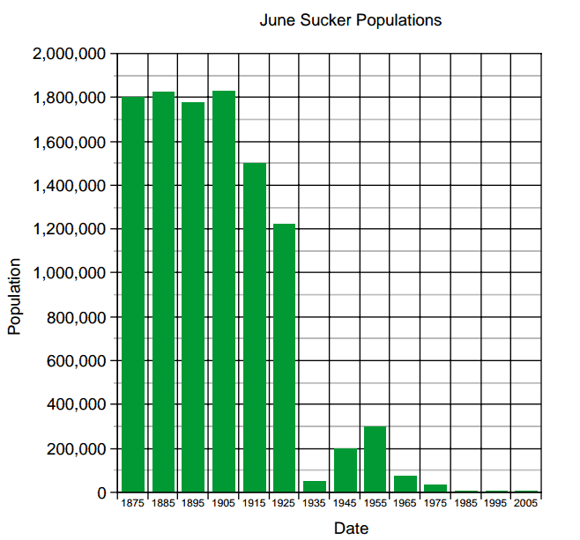

Step 3 – Applying the Concept

Writing Prompt: What needs to be done to restore Utah Lake to it original environment?

