Paper Spinner Directions

You will need:

- One spiral
- Scissors
- A short piece of cotton string
- A heat source (candle, hot plate, etc.)

1. Cut out the appropriate circle, then cut along the spiral.
2. Carefully cut a slit in the mark in the center.
3. Put the piece of string through the slit and knot the end to hold it in place.
4. Turn on the heat source.
5. Hold the string of the spinner above the heat source and watch it turn!

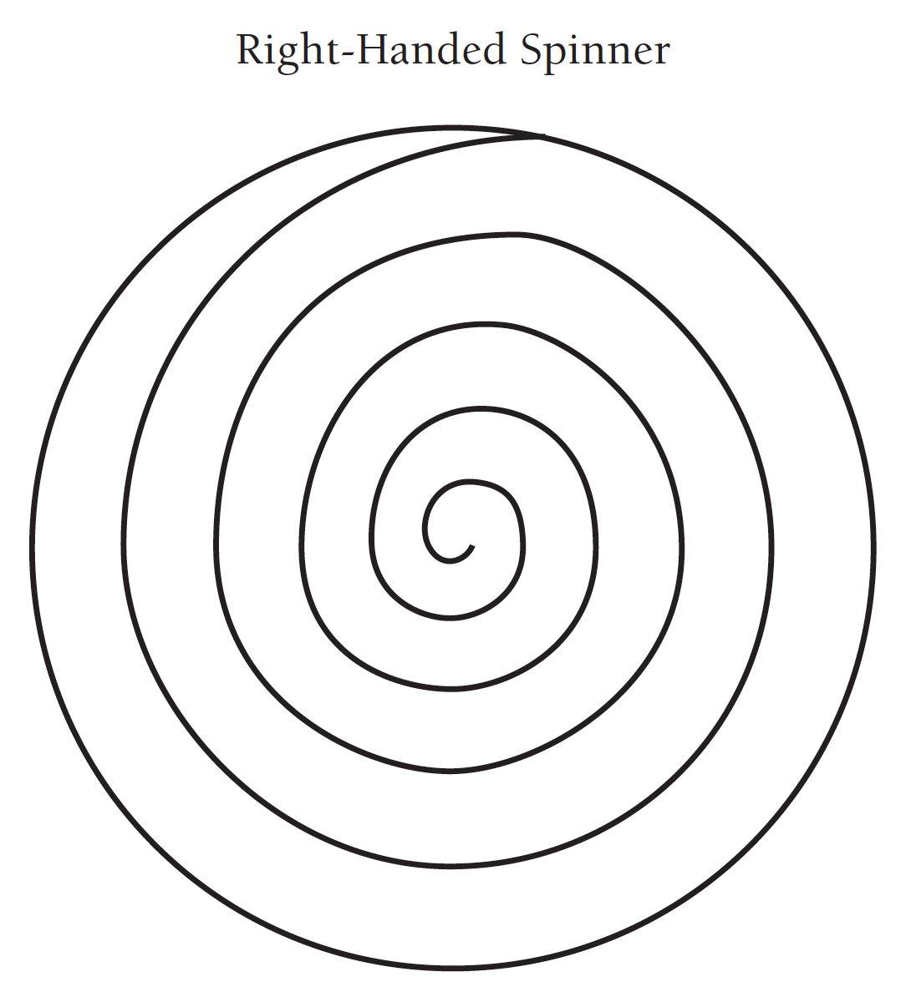

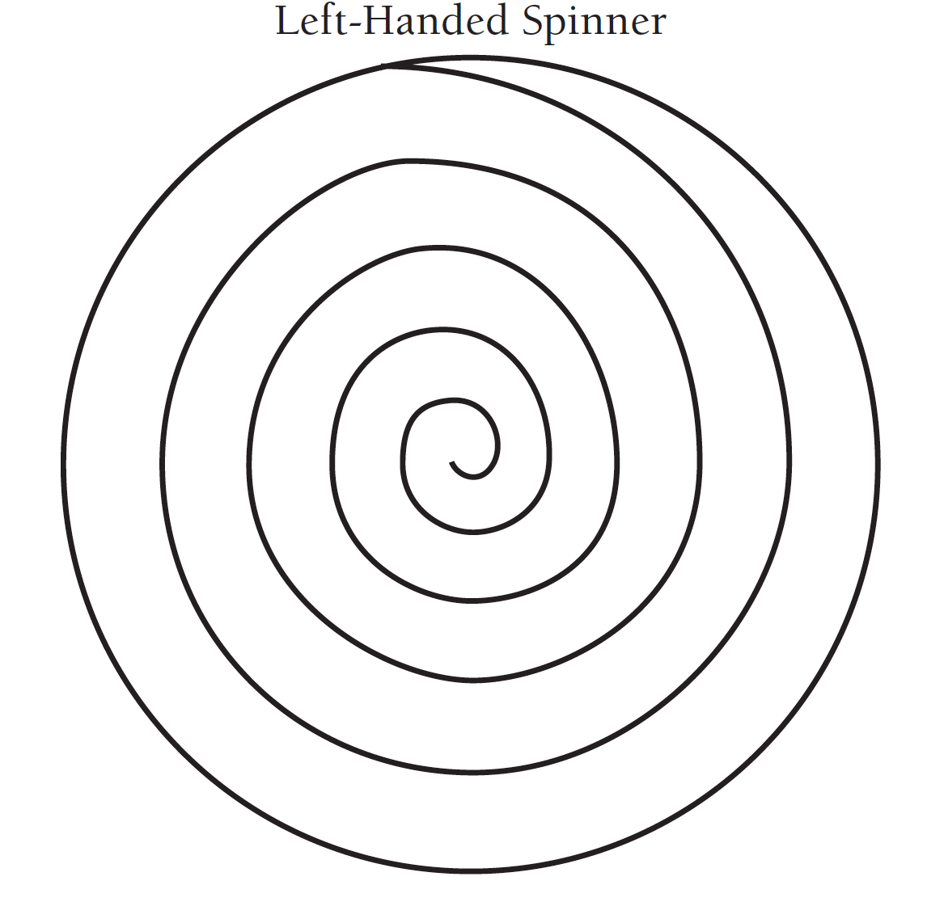
Big Spinner
