The Mars rover “Curiosity” is about to get its driver's license.
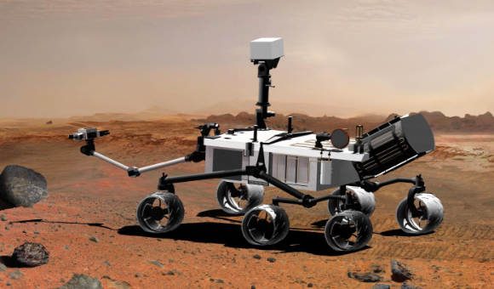

Mission control engineers in California
will spend the next four days remotely
installing new computer software in
Curiosity that allows the six-
wheeled vehicle to move around
the surface of the Red Planet.
The nuclear-powered rover, about
the size of a small sports car, can
only store so much pre-programmed
information in its computer at once,
having less memory capacity than a
typical cell phone.

Its previous flight-control software was built for the complex tasks of entering the atmosphere; descent and landing that brought the mobile science lab to a historic landing on Mars.
A new version of the software, uploaded to Curiosity while it was still traveling to Mars, is specially designed to let NASA engineers safely drive the rover, operate its robot arm, use its power drill, collect samples, sweep away dust and perform other functions as it goes about its science mission.
"Curiosity was born to drive. This software includes the capability for Curiosity to really go out and stretch her wheels," Benjamin Cichy, the rover's senior software and systems engineer, told reporters on Friday at the Jet Propulsion Laboratory near Los Angeles.
Curiosity arrived on Mars Sunday night on a quest for evidence that the planet most similar to Earth may once had microorganisms, or may even now be capable of supporting life.
The rover comes equipped with sophisticated instruments capable of analyzing samples of soil, rocks and atmosphere on the spot and beaming results back to Earth.
The principal target of its exploration is a 3-mile- (5-kilometer) high tower of layered rock, named Mount Sharp. Mt Sharp may have formed from sediment that once filled Gale Crater. Mars scientists see the mound as a potential gold mine of geologic study.
An initial review of data collected from Curiosity's arrival on Mars revealed that it blasted through the planet's thin atmosphere at 24 times the speed of sound.
"If you were a human riding on board, it'd be a little bit of a rough ride, but fortunately Curiosity is made of some tough stuff," said Gavin Mendeck, who oversaw the rover's entry. It landed just 1.5 miles from the center of its projected landing zone.

