Unit Resources: Water Cycle and Water Conservation

Pre-Assessment:

Freshwater 101 quiz – Paper version. (Take the interactive version at the end)

http://environment.nationalgeographic.com/environment/freshwater/freshwater-101-quiz/

Science
The Water Cycle: what is it? – interactive water cycle demos and activities

http://thewaterproject.org/resources/the_water_cycle_presentation.php
http://www.epa.gov/ogwdw/kids/flash/flash_watercycle.html
http://apps.southeastwater.com.au/games/se-water-cycle.swf
http://www.science-sparks.com/2012/07/30/make-a-mini-water-cycle/

A Drop in the bucket – lesson plan/water in a bucket demo
http://www.uen.org/Lessonplan/preview?LPid=31636

Why is it important to understand the water cycle? –

http://video.nationalgeographic.com/video/environment/freshwater/env-freshwater-whycare/

optional video from ESA (a look at salt water, currents, weather patterns, career perspective)

http://spaceinvideos.esa.int/Videos/2012/12/SMOS_-_ESA_s_water_mission

Water is a limited natural resource.

Only a small percentage is drinkable freshwater.

Of the drinkable freshwater there is an unequal distribution, and pollution makes water non-potable.

Freshwater and how it is used: video interactive
http://environment.nationalgeographic.com/environment/freshwater/freshwater-101-interactive/

http://environment.nationalgeographic.com/environment/freshwater/change-the-course/infographic/

Math and Writing
How much water do you use? lesson with table of water use for math
http://www.get2knowh2o.org/instructor/teach4.pdf
Science
The Human Water Cycle: modify the lesson for 4th grade, but good information about gray water, black water, and water conservation.
http://www.teachengineering.org/view_lesson.php?url=collection/cub_/lessons/cub_humanwatercycle/cub_humanwatercycle_lesson01.xml

What is the water outlook in Utah?

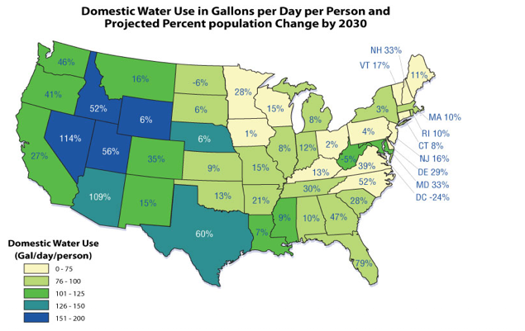
http://www.epa.gov/watersense/our_water/tomorrow_beyond.html
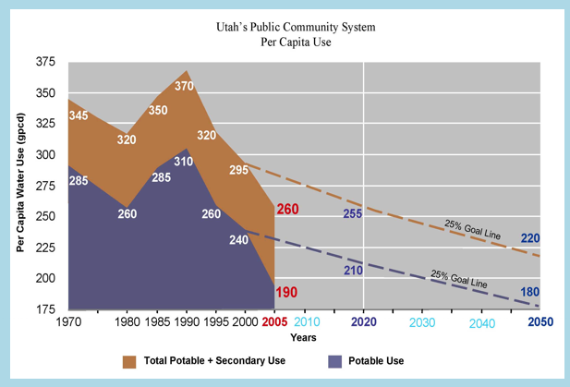
from: http://www.conservewater.utah.gov/Blog/Blog.html

Photo of Lake Powell – 2000 lake levels vs 2006 lake levels
http://earthobservatory.nasa.gov/IOTD/view.php?id=8132

Elephant Butte in New Mexico
http://climate.nasa.gov/state_of_flux#Elephant_Butte_930x607.jpg

Writing
What could be contributing to the lake levels? (Possible writing component? Incorporate information about the water cycle.)

Retake the Drinking Water and Sanitation Quiz

http://environment.nationalgeographic.com/environment/freshwater/drinking-water-and-sanitation-quiz/

Water Projects
Conserve water – water use
Preserve – keep it unpolluted
Harvest – store water, collect water, tap water in wells and aquifers, desalination of water

Dam Forces:
http://www.teachengineering.org/view_activity.php?url=collection/cub_/activities/cub_dams/cub_dams_lesson02_activity1.xml

Hydroelectric Dam demonstration:
http://www.ei.lehigh.edu/eli/energy/resources/handouts/labs/hydrodam_demo_teacher.pdf

Water Cycle HD ipad app $1.99

Additional activities:

Engineer a dam lesson plan
http://www.tryengineering.com/lessons/engineeradam.pdf

Water and dams in today’s world
http://www.teachengineering.org/view_lesson.php?url=collection/cub_/lessons/cub_dams/cub_dams_lesson02.xml

Sand Dam video of a dam project in Africa
http://thewaterproject.org/sand-dams.php

Saving Water Game: P.E. or outdoor game (using ice cubes might be an alternative)
http://www.get2knowh2o.org/instructor/exp_number.html

Drench – save your community by 2050
http://antenna.sciencemuseum.org.uk/waterwars/drench/

Leaky faucet -- Experiment for water conservation
http://www.uen.org/Lessonplan/preview.cgi?LPid=27247

The water cycle or crisis:
http://thewaterproject.org/resources/download/water-cycle-water-crisis.pdf

Harvesting Rainwater: Utah (First paragraph of the article, could be incorporated into the lesson plan – engineering project, create a system to harvest rainwater)
http://www.conservewater.utah.gov/Rainwater%20Harvesting/RWHwebpage3A.pdf

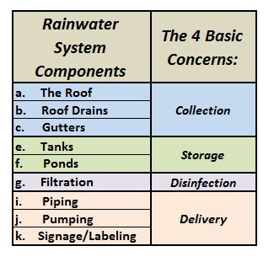

Engineering Problem: Design a hand-washing unit that will allow individuals in developing companies to maintain sanitation stations and conserve water.
http://www.tippytap.org/videos

