Grade 6

Standard 3 Telemetry

Performance Test 1

Activity Description: Students will send a message to a partner that will decode it in asimilar way to real space communications.
Materials Needed: grid sheet, pictures of simple objects
Prior to Assessment: Students should know that messages traveling through space must be sent via electromagnetic rays such as light or radio waves. A picture is sent using a code which a computer then decodes. The computer places a dot of the correct shade in a space (called a pixel) and makes row after row of dots. A picture emerges.
Time Needed: one and one half hours
Procedure
1. Students must work in pairs. Each should have a worksheet with a picture to "send" and an empty grid to "receive".
2. Both students need to code their picture. Each square needs to be assigned a number.
Use a key like this:
o = no color or white 1 = gray 2 = black
3. Students will have to decide if partially filled squares count as a color or not. They cannot be partially filled.
4. One student should "send" their picture to the other by reading off the numbers they established. The "receiving" student should fill in their grid and try to guess what the picture is.
5. When one student has finished the other can "send."
6. See attached worksheets
Grading Scale
Student successfully codes own picture 5 pts
Student successfully receives and decodes partner's picture 5 pts
Student correctly answers questions on worksheet. 5 pts
Answers will vary.
The translated picture is blocky and not very clear.
They are sent by sound waves
No, they are sent by light or radio waves
The picture would be destroyed.

Student worksheets:
Directions:
1. One grid on your paper has a picture on it. You will “send” this picture to a partner. Use this code:
o = no color or white 1 = gray 2 = black
2. Read your numbers to your partner who will fill in the empty grid on the bottom of his/her paper. He/she will guess what the picture is.
3. Reverse the process and have your partner read you his/her numbers.
4. Answer the questions when you are finished.
Questions:
1. Were you able to guess what the picture was that was sent to you?
2. How was the translated picture different from the real one?
3. You sent the picture to your partner using what type of waves?
4. Are pictures sent through space on these same waves?
5. What would happen if you used a different size grid than the sender? (with more rows or columns?)

Picture 1
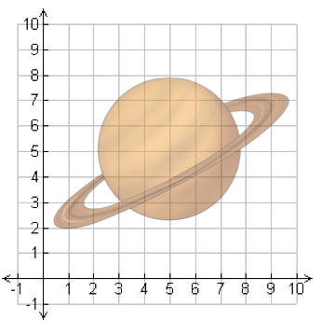

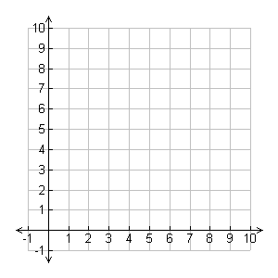

Picture 2

