Water Outlook in Utah

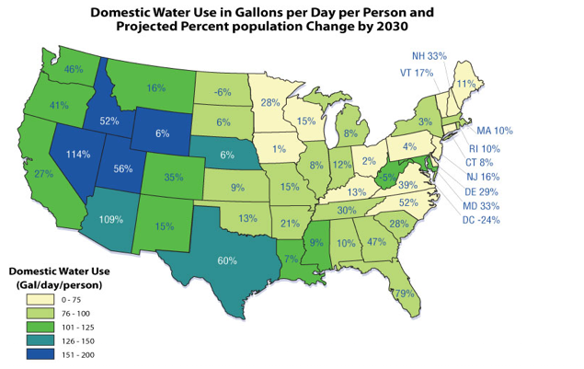
http://www.epa.gov/watersense/our_water/tomorrow_beyond.html

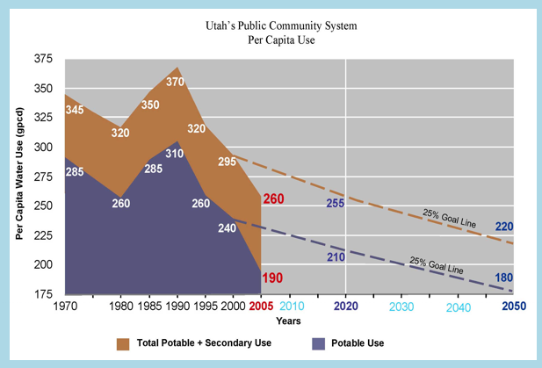

from: http://www.conservewater.utah.gov/Blog/Blog.html

