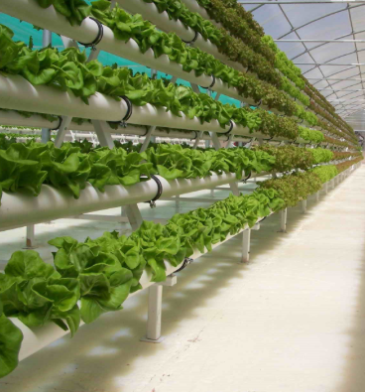
HYDROPONICS
Hydroponics is a way of growing plants without
soil. It can be used just about anywhere,
but it's particularly useful for small gardens,
for greenhouses, or for delicate plants that are
easily damaged outdoors. Hydroponics is one
of the fastest growing areas of farming today,
not only among backyard gardeners, but also in
its use for commercial growing of cut flowers,
berries and many vegetables.

Green plants are the basis of all life on Earth. They take in water and carbon dioxide from the air and give off the oxygen we breathe and sugars that form our foods. Plants also need nutrients from the soil that are naturally found there or sometimes added as fertilizers. It is quite amazing how a large tree can be made from a cup of fertilizer, water and lots and lots of air!

Green plants need soil to hold them in place and store water. The roots hold on very tightly to the soil, as you may know if you have ever tried to pull weeds! Hydroponics is a way to keep plant roots wet and support the plant without the soil.
The Benefits of Hydroponics
Hydroponic gardening offers several benefits to our environment. Hydroponic gardening uses considerably less water than soil gardening, because of the constant reuse and recycling of the water. Hydroponic plants are often grown indoors where there are few bug pests.
Some parts of the world lack good soil and lots of water. Hydroponics works anywhere that the sun shines, even in a city. Some cities are growing “walls” of green plants and produce lettuce, tomatoes and cucumbers right inside a building.
Growing Mediums
The purpose of a growing medium is to provide holes for air and support the root system of the plant and to channel the water and nutrients. Different growing mediums work well in different types of hydroponic systems. Gravel can be a good medium if you want it to drain quickly. Paper towels are good if you want it to hold on the water longer.

Other commonly used growing mediums are ground-up wood or coconut shells, vermiculite and different kinds of sand. Some mediums are hold too much moisture and should be used with plants that are like having wet roots.
Nutrients or Fertilizers
A hydroponic nutrient solution contains water and all the nutrients that the plant normally would get from the soil. You can get the nutrients as a liquid or powder that mixes with water. Be careful not to add too much, they can damage the plant.
Water Systems

Some hydroponic farmers have drip and pump systems to automatically water their plants. Some systems rely on gravity to pull water down a row of plants. It is important not to waste water because some places do not have enough water and water adds to the expense of raising the crops.

