[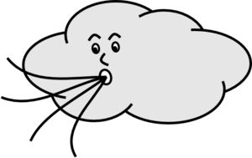](javascript:edit(69747))O

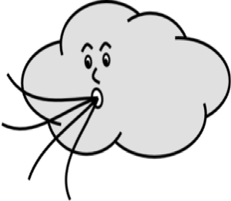

Clouds



Clouds



Clouds



Clouds

Stay

Plant

Stay



Clouds

Stay

Stay

Ocean

Stay

Clouds

Clouds

[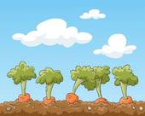](http://www.google.com/url?sa=i&rct=j&q=&esrc=s&source=images&cd=&docid=hPXXVLuWlxN-JM&tbnid=qtDH6RcynI7nhM:&ved=0CAUQjRw&url=http://www.fotosearch.com/illustration/cultivating-soil.html&ei=UwlLUoWtLKnkyQHjsIDQCg&bvm=bv.53371865,d.aWc&psig=AFQjCNFJq_BLls0qzj_4TUjuGI7aIsEGrg&ust=1380735505040316)

Soil

Soil

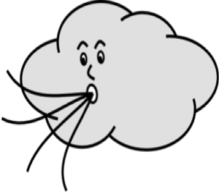

Clouds



Clouds

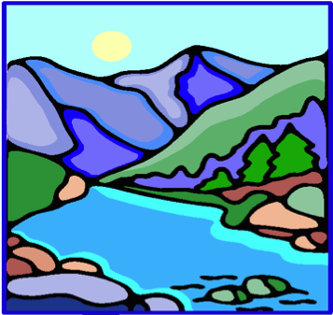

River

Stay

Stay

[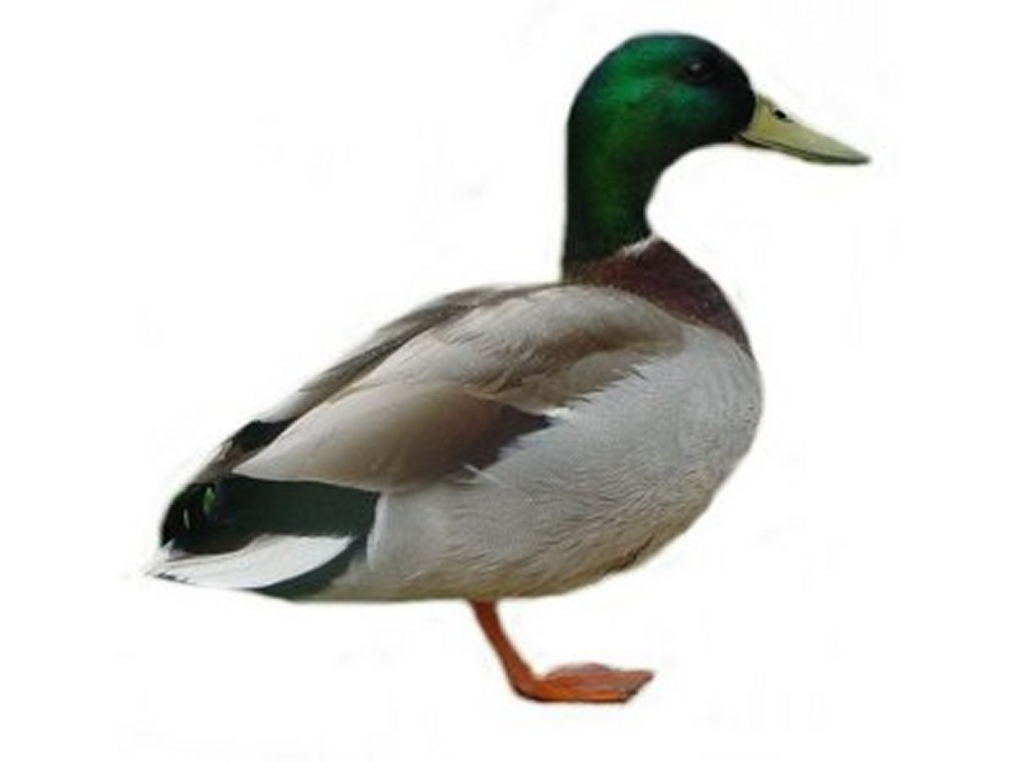](http://www.google.com/url?sa=i&rct=j&q=&esrc=s&source=images&cd=&docid=YauMHuS_JrMuuM&tbnid=aRjNucfLu-PZiM:&ved=0CAUQjRw&url=http://www.freeclipartpictures.com/clipart/animals52.htm&ei=Og5LUoSFFOnWyQHdqoCQBg&bvm=bv.53371865,d.aWc&psig=AFQjCNHn1Yq6jTLzeqamVyBSXh5uvrDbEg&ust=1380736892612454)

[](http://www.google.com/url?sa=i&rct=j&q=&esrc=s&source=images&cd=&docid=hPXXVLuWlxN-JM&tbnid=qtDH6RcynI7nhM:&ved=0CAUQjRw&url=http://www.fotosearch.com/illustration/cultivating-soil.html&ei=UwlLUoWtLKnkyQHjsIDQCg&bvm=bv.53371865,d.aWc&psig=AFQjCNFJq_BLls0qzj_4TUjuGI7aIsEGrg&ust=1380735505040316)

Lake

Animal

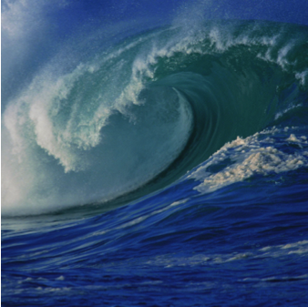

Ocean

Soil

Stay

[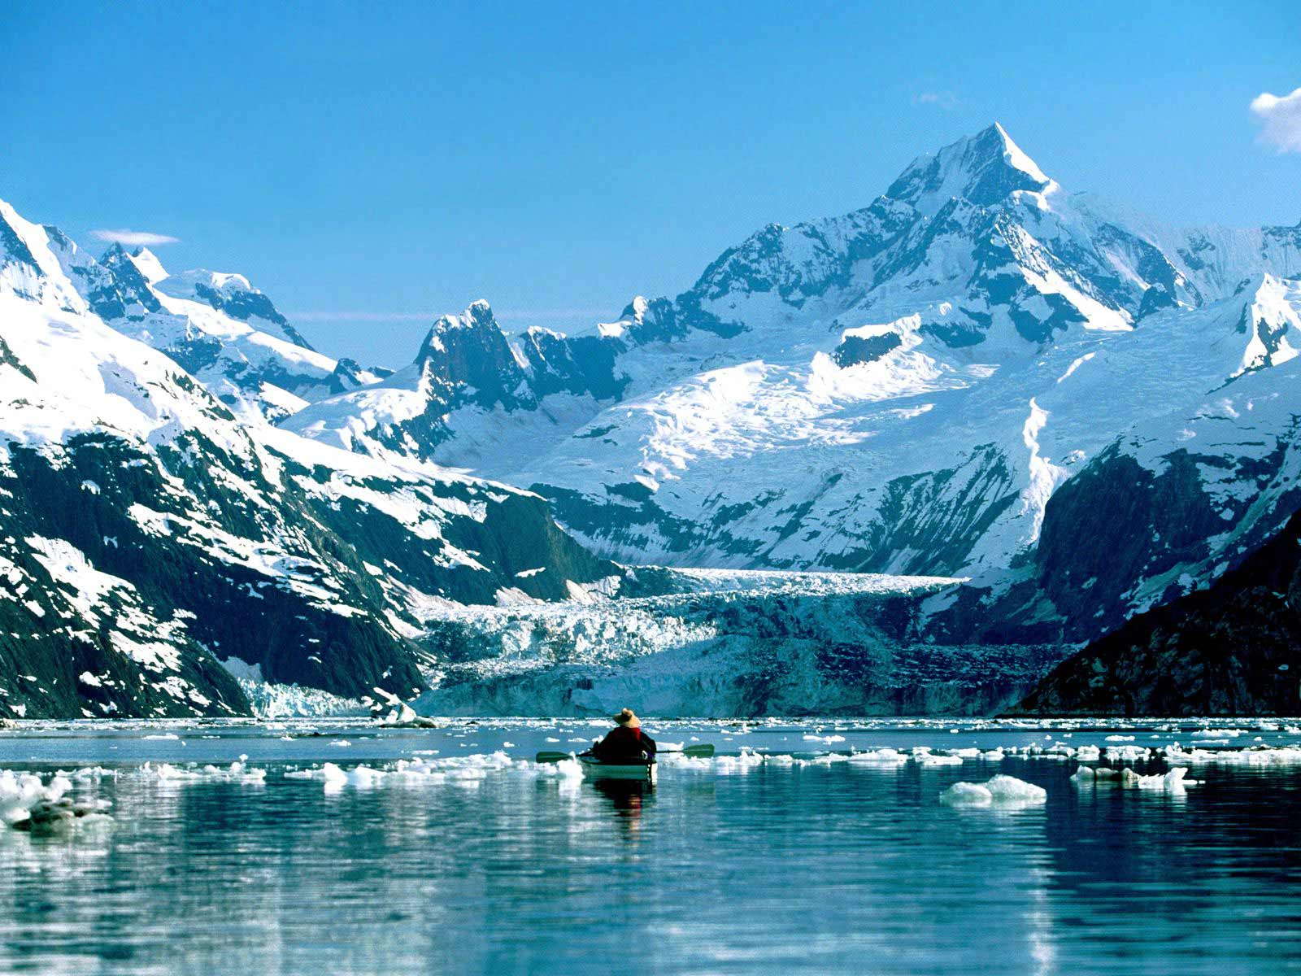](http://www.google.com/url?sa=i&rct=j&q=&esrc=s&source=images&cd=&docid=4KJlCG9HiqNhTM&tbnid=G89HndjQ8FR11M:&ved=0CAUQjRw&url=http://www.fantom-xp.com/fr_42__Kaya_king_Glacier_Bay.html&ei=fxJLUqWGAaPEyQGf3oHYDg&psig=AFQjCNF3Z0P3LN0EhDghQqOzi6BTxxPwNg&ust=1380738007650981)[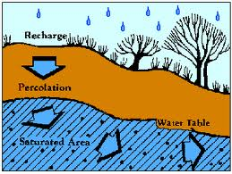](http://www.google.com/imgres?client=firefox-a&hs=unl&rls=org.mozilla:en-US:official&biw=1229&bih=609&tbm=isch&tbnid=nzG9SiyP-ln1rM:&imgrefurl=http://techalive.mtu.edu/meec/module06/Recharge.htm&docid=Rn6Uv5qpGhhTcM&imgurl=http://techalive.mtu.edu/meec/module06/images/recharge.gif&w=350&h=263&ei=0hdLUpqCDom9yAGou4HAAg&zoom=1&ved=1t:3588,r:31,s:0,i:189&iact=rc&page=3&tbnh=180&tbnw=259&start=26&ndsp=13&tx=138&ty=115)[](http://www.google.com/url?sa=i&rct=j&q=&esrc=s&source=images&cd=&docid=YauMHuS_JrMuuM&tbnid=aRjNucfLu-PZiM:&ved=0CAUQjRw&url=http://www.freeclipartpictures.com/clipart/animals52.htm&ei=Og5LUoSFFOnWyQHdqoCQBg&bvm=bv.53371865,d.aWc&psig=AFQjCNHn1Yq6jTLzeqamVyBSXh5uvrDbEg&ust=1380736892612454)[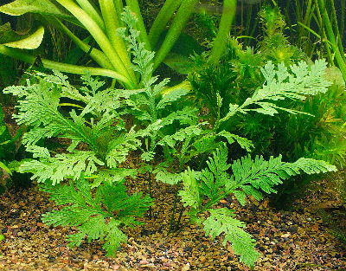](http://www.google.com/url?sa=i&rct=j&q=&esrc=s&source=images&cd=&docid=nxspA1jFYDKP7M&tbnid=_3ICxT0eLk_v5M:&ved=0CAUQjRw&url=http://aquaticplants.animal-world.com/&ei=WBtLUoKDK_KgyAH-_YCADQ&bvm=bv.53371865,d.aWc&psig=AFQjCNHbU21Ajd5JBItTwbm2OloedYhj2A&ust=1380740293114463)[](http://www.google.com/imgres?client=firefox-a&hs=unl&rls=org.mozilla:en-US:official&biw=1229&bih=609&tbm=isch&tbnid=nzG9SiyP-ln1rM:&imgrefurl=http://techalive.mtu.edu/meec/module06/Recharge.htm&docid=Rn6Uv5qpGhhTcM&imgurl=http://techalive.mtu.edu/meec/module06/images/recharge.gif&w=350&h=263&ei=0hdLUpqCDom9yAGou4HAAg&zoom=1&ved=1t:3588,r:31,s:0,i:189&iact=rc&page=3&tbnh=180&tbnw=259&start=26&ndsp=13&tx=138&ty=115)[](http://www.google.com/url?sa=i&rct=j&q=&esrc=s&source=images&cd=&docid=nxspA1jFYDKP7M&tbnid=_3ICxT0eLk_v5M:&ved=0CAUQjRw&url=http://aquaticplants.animal-world.com/&ei=WBtLUoKDK_KgyAH-_YCADQ&bvm=bv.53371865,d.aWc&psig=AFQjCNHbU21Ajd5JBItTwbm2OloedYhj2A&ust=1380740293114463)

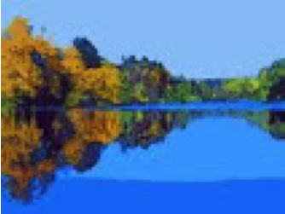

Lake

Glacier



River

Glacier



River



Ocean



Clouds



Clouds

Stay

Stay

Cloud



Lake



Riverer

Groundwater

River

Animal



Clouds

Stay

Stay

Groundwater



Lake



Lake

Stay

Stay

Stay



Clouds

Groundwater

Plants



Clouds



Riverer

Plant

Stay